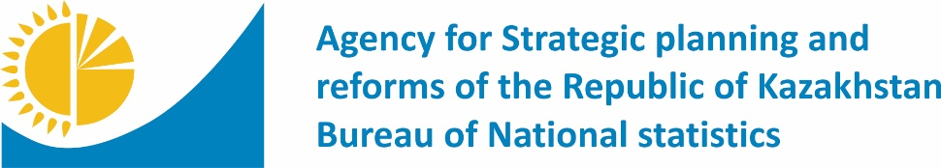 | 
 | www.stat.gov.kz
Press release | №  March 15, 2021

Demographic situation for January 2022

The population of the country as of February 1, 2022 amounted to 19143.2 thousand people, including urban – 11389.2 thousand people (59.5%), rural – 7754.0 thousand people (40.5%). Compared to February 1, 2021 the population increased by 245.3 thousand people or 1.3%.
thousand people
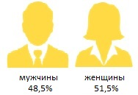
мужчины женщины
48.6% 51.4%

Natural increase
Natural population increase of the republic in January 2022 compared to January 2021 (21.7 thousand people) decreased by 17.3% and amounted to 17.9 thousand people. Natural population increase rate amounted to 10.98 people per 1000 population.
As a result of processing the information contained in the СIVIL status provided by civil register offices, in January 2022 the number of births amounted to 31.2 thousand people, which is 8.7% less than in January 2021 (34.2 thousand people). Crude birth rate amounted to 19.10 births per 1000 population.
In the period under review the number of deaths amounted to 13.3 thousand people, which is 6.3% more than in January 2021 (12.5 thousand people). Crude death rate amounted to 8.12 deaths per 1000 population.
In January 2022, 274 infant deaths under one year of age were registered in the republic. Compared to January 2021 (241 infant deaths) increased by 13.7%. Infant mortality rate amounted to 8.79 per 1000 live births.
Population migration
As a result of processing the information provided by migration authorities, in January 2022, 1291 immigrants were registered in the country, number of emigrants amounted to 1592 people, net-migration -301 people.
The main migration exchange of the country takes place with the CIS countries. The share of immigrants and emigrants to and from CIS countries amounted to 90.0% and 79.5% of the total number of migrants.
The number of internal migrants decreased by 25.2% compared to January-December 2020. In terms of interregional migration, a positive net-migration was formed in 3 regions of the country: Nur-Sultan (2777 people), Almaty (2332 people), Shymkent (212people) cities.

www.stat.gov.kz / Official statistics / By industry / Demographic statistics
Performer:  Assem Aldangarkyzy  Tel. +7 7172 74 90 02 | Director of Department:  Nurlan Khanzhigitov  Tel. +7 7172 74 90 61 | Press service:  Assem Aldangarkyzy  Tel. +7 7172 74 90 02  E-mail: aldangarkyzy@aspire.gov.kz | Address:  010000, Nur-Sultan  Mangilik El street, 8  House of Ministries, entrance 4
© Agency for Strategic planning and reforms of the Republic of Kazakhstan Bureau of National statistics

